23CSE202 DATABASE MANAGEMENT SYSTEMS
S3 B.Tech CSE
Department of Computer Science and Engineering
Amrita School of Computing, Amritapuri Campus

3. Database Design Document

Group No :D2
Team Members :
Roll No | Student Name
AM.SC.U4CSE25304 | Avinash Menon MMMmMMMutMuthirach
AM.SC.U4CSE25306 | Arav D A
AM.SC.U4CSE25310 | Boomish Saravanan
AM.SC.U4CSE25311 | Chevuru Neekshitha

Project Title : FinTrack – Personal Finance Management System

3.1. Detailed description of the project
FinTrack is a personal finance management system that lets a registered user track accounts, transactions, categories, budgets, and savings goals. Each user authenticates with a unique email and can only view or modify their own data.

Business Rules
- A user is identified by a unique user_id and email.
- A user can hold multiple accounts and designate one as default.
- Categories are either shared defaults or custom, owned by one user.
- Every transaction belongs to one user, one account, one category; type is Income/Expense; amount > 0.
- A budget can cover several categories, each with its own allocated amount; end_date ≥ start_date.
- A savings goal has target_amount > 0, saved_amount ≥ 0, and may link to an account.
- One user's data is never visible to another.
- Deleting a user cascades to all their owned records.

3.2. ER Diagram
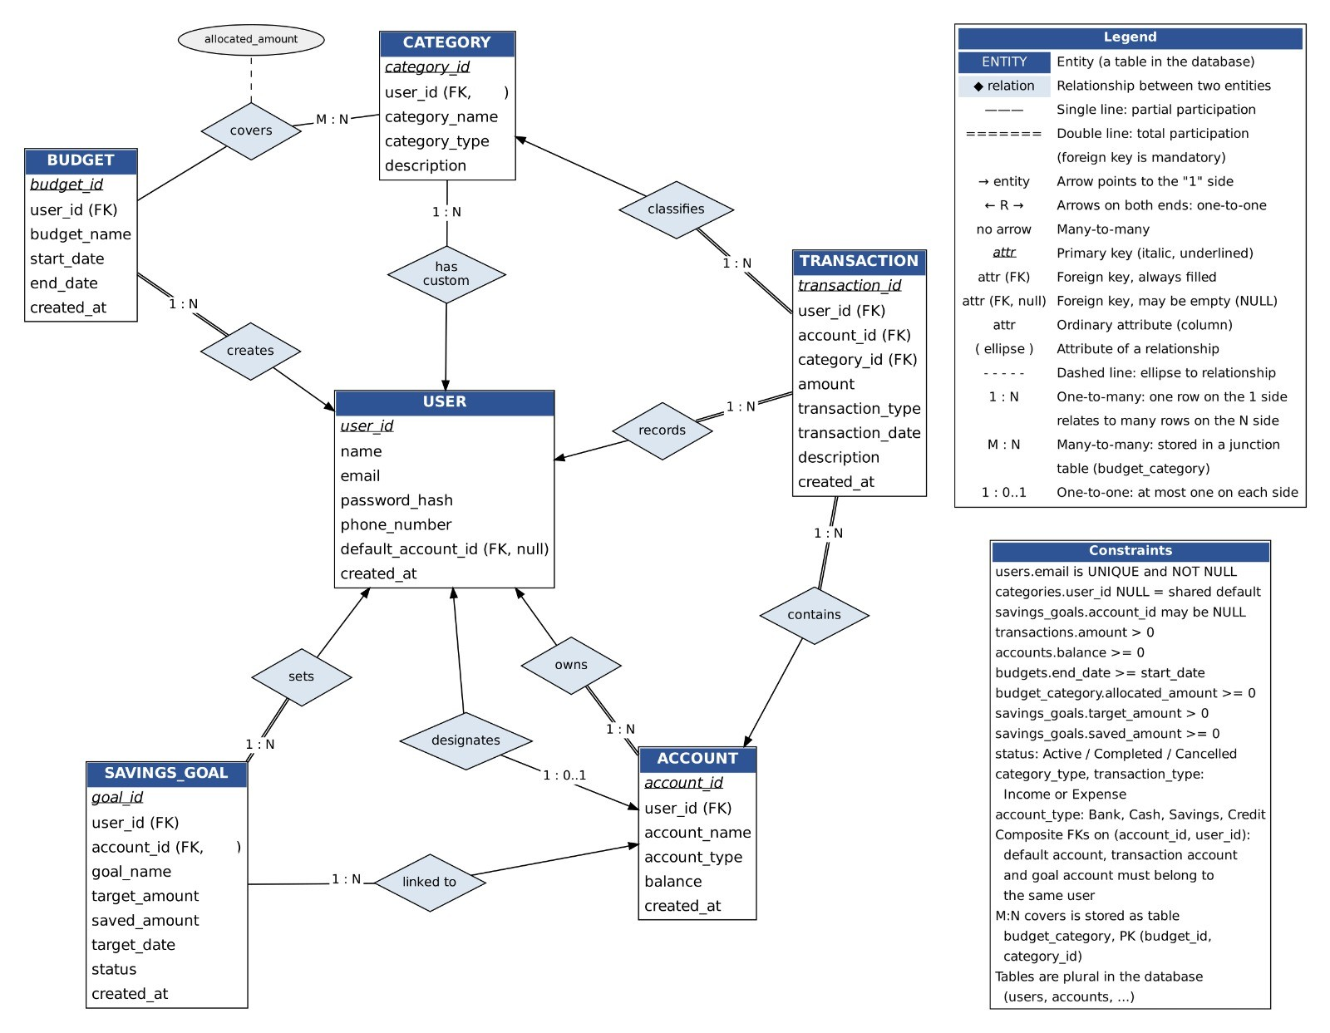
Entities, Keys, Cardinality and Participation — Summary
Entity | Primary Key | Related To | Cardinality | Participation
User | user_id | Account, Category, Transaction, Budget, Savings Goal | 1:N (owns/has custom/makes/creates/sets); 1:1 (designates) | User: partial throughout · Child: mostly total (Category partial)
Account | account_id | User, Transaction, Savings Goal | N:1 with User (owns) · 1:1 with User (designates) · 1:N with Transaction, Savings Goal | Account: total in owns · partial in designates/tracks in
Category | category_id | User, Transaction, Budget | N:1 with User (partial) · 1:N with Transaction · M:N with Budget | Category: partial throughout
Transaction | transaction_id | User, Account, Category | N:1 with each | Transaction: total on all three
Budget | budget_id | User, Category | N:1 with User · M:N with Category (via covers) | Budget: total with User · partial with Category
Savings Goal | goal_id | User, Account | N:1 with User · N:1 with Account (partial) | Goal: total with User · partial with Account

3.3 Relational Schema
Every 1:N relationship is implemented by placing the primary key of the "1" side as a foreign key in the "N" side relation. The one genuine many-to-many relationship (Budget ↔ Category, "covers") requires its own junction relation, BUDGET_CATEGORY, carrying the relationship's own attribute, allocated_amount. This gives seven relations in total. Primary keys are underlined; foreign keys are marked (FK).
USER
USER ( user_id , name, email, password_hash, phone_number, default_account_id (FK, null), created_at )
- Primary Key: user_id
- Alternate Key: email (UNIQUE, NOT NULL)
- Foreign Key: default_account_id → ACCOUNT(account_id), nullable, ON DELETE SET NULL
ACCOUNT
ACCOUNT ( account_id , user_id (FK), account_name, account_type, balance, created_at )
- Primary Key: account_id
- Foreign Key: user_id → USER(user_id), NOT NULL, ON DELETE CASCADE
- Design note: USER.default_account_id and ACCOUNT.user_id form a circular reference. In practice this is resolved by (a) creating the USER row first with default_account_id left NULL, (b) inserting that user's ACCOUNT row(s), then (c) issuing an UPDATE on USER to set default_account_id — or by deferring the foreign-key check until COMMIT if the RDBMS supports deferred constraints.
CATEGORY
CATEGORY ( category_id , user_id (FK, null), category_name, category_type, description )
- Primary Key: category_id
- Foreign Key: user_id → USER(user_id), nullable — NULL means a shared system-default category; a non-NULL value means a custom category owned by that user.
TRANSACTION
TRANSACTION ( transaction_id , user_id (FK), account_id (FK), category_id (FK),
amount, transaction_type, transaction_date, description, created_at )
- Primary Key: transaction_id
- Foreign Keys: user_id → USER(user_id) · account_id → ACCOUNT(account_id) · category_id → CATEGORY(category_id)
- Check constraints: amount > 0 ; transaction_type IN ('Income','Expense')
BUDGET
BUDGET ( budget_id , user_id (FK), budget_name, start_date, end_date, created_at )
- Primary Key: budget_id
- Foreign Key: user_id → USER(user_id)
- Check constraint: end_date >= start_date
- Note: budget_id no longer carries a category_id directly — a budget's categories are recorded in BUDGET_CATEGORY below, since one budget plan can now cover several categories.
BUDGET_CATEGORY (junction relation for the Budget ↔ Category many-to-many relationship)
BUDGET_CATEGORY ( budget_id (FK), category_id (FK), allocated_amount )
- Primary Key: composite (budget_id, category_id)
- Foreign Keys: budget_id → BUDGET(budget_id) · category_id → CATEGORY(category_id)
- Check constraint: allocated_amount > 0
SAVINGS_GOAL
SAVINGS_GOAL ( goal_id , user_id (FK), account_id (FK, null), goal_name, target_amount, saved_amount, target_date, status, created_at )
- Primary Key: goal_id
- Foreign Keys: user_id → USER(user_id), NOT NULL, ON DELETE CASCADE · account_id → ACCOUNT(account_id), nullable
- Check constraints: target_amount > 0 ; saved_amount >= 0 ; status IN ('Active','Completed','Cancelled')

3.4 Normalization and Functional dependency analysis
Functional Dependencies (FDs):
- Users: {user_id} → {name, email, password_hash, phone_number, default_account_id, created_at}; {email} → same set (email is UNIQUE).
- Accounts: {account_id} → {user_id, account_name, account_type, balance, created_at}.
- Categories: {category_id} → {user_id, category_name, category_type, description}.
- Transactions: {transaction_id} → {user_id, account_id, category_id, amount, transaction_type, transaction_date, description, created_at}; also {account_id} → {user_id} (inherited from Accounts).
- Budgets: {budget_id} → {user_id, budget_name, start_date, end_date, created_at}.
- Budget_Category: {budget_id, category_id} → {allocated_amount}.
- Savings_Goals: {goal_id} → {user_id, account_id, goal_name, target_amount, saved_amount, target_date, status, created_at}.
Candidate Keys & Attribute Closure: For Users, {user_id}+ and {email}+ both yield every attribute, so both are candidate keys; user_id is chosen as PK. For Accounts, Categories, Budgets and Savings_Goals, the closure of the single id attribute yields all attributes in each relation, so each id is the sole candidate key. For Transactions, {transaction_id}+ yields all attributes, but {account_id, category_id}+ only yields {account_id, category_id, user_id} — not the full set — so transaction_id is the only candidate key. For Budget_Category, neither budget_id nor category_id alone determines allocated_amount; only the pair does, so the composite (budget_id, category_id) is the sole candidate key, as expected for a many-to-many junction table.
1NF (First Normal Form): All relations satisfy 1NF because each attribute stores a single, atomic value, and there are no repeating groups or lists of values within a single field. For example, multiple transactions are stored as separate rows rather than as a list inside an account record. The many-to-many relationship between Budgets and Categories is represented through the separate Budget_Category relation, avoiding the storage of multiple category values in a single budget field.
2NF (Second Normal Form): All relations with single-attribute candidate keys satisfy 2NF automatically, since a partial dependency on part of a single-attribute key is not possible. The Budget_Category relation also satisfies 2NF because its non-key attribute, allocated_amount, depends on the complete composite key (budget_id, category_id) rather than on either attribute individually. Therefore, there are no partial dependencies of non-key attributes on a proper subset of a candidate key.
3NF (Third Normal Form) & BCNF (Boyce–Codd Normal Form): The relations Users, Accounts, Categories, Budgets, Budget_Category, and Savings_Goals satisfy BCNF under the functional dependencies listed above, since every non-trivial determinant is a candidate key or superkey.
However, Transactions violates both 3NF and BCNF under the stated functional dependencies. The relation contains the dependencies transaction_id → account_id and account_id → user_id, producing the transitive dependency transaction_id → account_id → user_id. Since account_id is not a superkey of Transactions and user_id is a non-prime attribute, this dependency violates the requirements of 3NF and BCNF.
The user_id attribute is retained in Transactions as part of the implemented design to support convenient user-level access checks and per-user queries. The composite foreign key (account_id, user_id) references (account_id, user_id) in Accounts, helping ensure that a transaction is associated with an account belonging to the specified user. This is an intentional design choice, but it does not eliminate the transitive dependency for normalization purposes.

